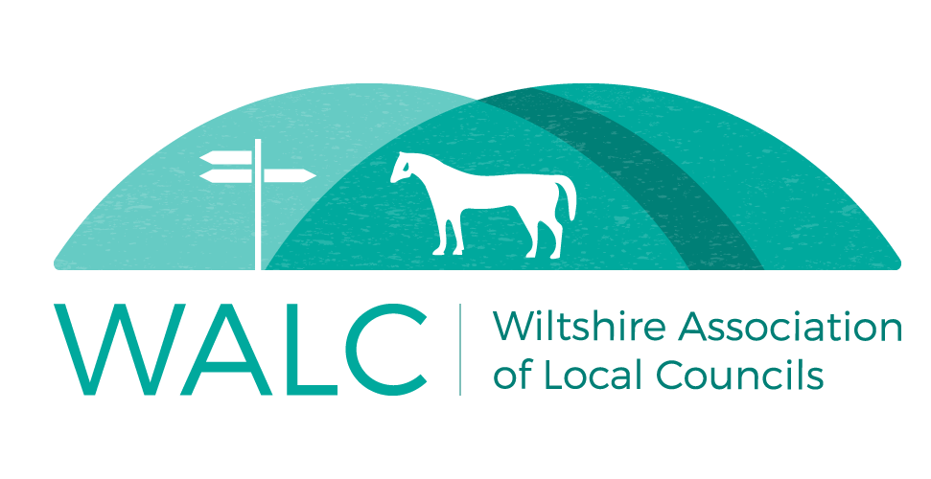

Protocol for Remote Meetings
Broad Chalke Parish Council
1.0. Introduction
1.1. On 4th April 2020 the Government introduced The Local Authorities and Police and Crime Panels (Coronavirus) (Flexibility of Local Authority and Police and Crime Panel Meetings) (England and Wales) Regulations 2020 which allows local councils to meet remotely. These regulations apply to meetings held before 7th May 2021.
In order to meet the regulations, the following conditions must be satisfied.
Members in remote attendance must be able:
  - to hear, and where practicable see, and be so heard and, where practicable, be seen by, the other members in attendance,
  - to hear, and where practicable see, and be so heard and, where practicable, be seen by, any members of the public entitled to attend the meeting in order to exercise a right to speak at the meeting, and
  - to be so heard and, where practicable, be seen by any other members of the public attending the meeting.
2.0. Technology
2.0. For the purposes of holding remote meetings, Broad Chalke Parish Council
Council will use Zoom.
2.1. Guidance on how to use the video-conferencing platform will be circulated to all members and officers and will be publicly available on the Council’s website.
2.2. Members or officers will advise the Clerk of any technical issues relating to access to these meetings.
3.0. Preparation for Meetings
3.1. The meeting will be advertised on the Council’s website and all members and officers due to attend will be issued with a notice and agenda by email. This will be within the usual timeframe for meeting notices.
3.2. All non-confidential meeting papers will be available on the Council’s website.
3.3. Minutes will be taken in the usual way and displayed on the website. Minutes will be circulated after the meeting and signed at a future face-to-face meeting once restriction have been lifted.
3.4. Where a member is unable to attend a meeting, apologies will be submitted and received in the usual way.
3.5. The meetings will be open to the public and ways of accessing the meeting will explained on the agenda (or on the meeting notice).

3.6. The same standards of behaviour are applied to remote meetings as to physical meetings. All members are bound by the Council’s Code of Conduct.
Members, officers and members of the public are asked to be patient with those who are less experienced in such meetings.
3.7. Members and officers in attendance at the meeting are reminded to check the background of their video range in order to ensure confidentiality, data protection and Code of Conduct requirements are met.
3.8. It is possible that technical issues may arise. It may be necessary for the host to request clarification or ask for dialogue to be repeated to make sure everyone can be heard and that they have the correct information for the minutes.
3.9. Those in attendance are asked to physically raise their hands when they wish to speak. Anyone dialing in by telephone will be advised of a word to use to enable them to “raise a hand” vocally. The Chairman of the meeting will advise the Meeting who is next to speak. Once advised the next speaker will unmute their screen to speak and then mute once they have finished speaking. Normal time limits on speaking apply.
3.10. Where a councillor has an interest in a matter and would normally leave a physical meeting, they will exit the meeting. They will either wait in the virtual “waiting room” or leave completely and be advised by text message (by the Clerk) when they can return to the meeting.
3.11. It may be necessary for members to prepare themselves for the meeting in a different way than usual. Where members do not have access to a printer, it may be necessary to familiarise themselves with the agenda and any reports beforehand.
4.0. The Meeting
4.1. The Clerk of the Council will set up and technically host the meeting. An email invitation, with an explanation of how to access the meeting, will be sent to all members,
4.2. Councillors are asked to ensure they are in a place with as little background noise as possible. Once checks have been carried out to ensure that everyone in attendance can be heard, all those in attendance are asked to “mute” their microphones until such a time as they are ready to speak. This eliminates background and feedback as well as ensures people are not talking over one another as there can sometimes be a time delay. Where this is not done, the host of the meeting may mute attendees
4.3. Whilst the Clerk is hosting the meeting, it will be chaired in the usual manner. There is a possibility that there will be more input from the Clerk than is usual given that, where members do not have access to a printer, it is possible that they will not be able to use the computer video function and look at the agenda and/or supporting papers at the same time.
4.4. It is possible that the meeting will be recorded (via the video conferencing platform itself). This is to aid the writing of minutes in a situation where the minute-taker is involved with technical aspects of the meeting as well as for openness and transparency.

4.5. If a vote is required, those attending by video will be asked to raise their hand until they have been advised that their vote has been recorded. Any members attending by telephone will be asked to express their vote vocally.
4.6. If you have difficulty hearing or being heard throughout the meeting, you are asked to advise the Clerk via the text “chat” function. Please be aware that this can be seen by everyone in attendance.
5.0. Public Participation
5.1. The agenda will invite the public to attend and will include information of how to access meetings.
5.2. The usual public participation session will take place. Members of the public are reminded that the Council cannot make any decisions on matters that do not appear on the agenda. If members of the public have questions about matters not on the agenda, they are requested to contact the Clerk outside of the meeting.
5.4. The meeting host may remove anyone from the meeting who is being intentionally disruptive, using offensive language or incessantly interrupting the meeting proceedings.
6.0. Relation to other policies and procedures
6.1. The Clerk will ensure that Data Protection requirements are followed when organising remote meetings
6.2. Members of the Council and members of the public are asked to ensure that they do not breach the General Data Protection Regulations (GDPR) and general confidentiality when they contribute to the meeting.
6.3. Where relevant, the Council’s Privacy Notices will be amended to incorporate remote meetings
6.4. Where relevant, the Council’s Risk Assessment will be amended to incorporate remote meetings.

NOTES: The Council has not signed up to a Premium service with Zoom and so meeting time is limited to 40 minutes. This MAY be extended at the end of the Meeting session by all participants exiting the meeting and then using the meeting invite for the first meeting to sign in again. The Clerk and or Chairman will advise accordingly 5 minutes prior to the session time limit.
WALC template amended by:
Mr C Rothwell
Clerk, Broad Chalke Parish Council
21 April 2020

